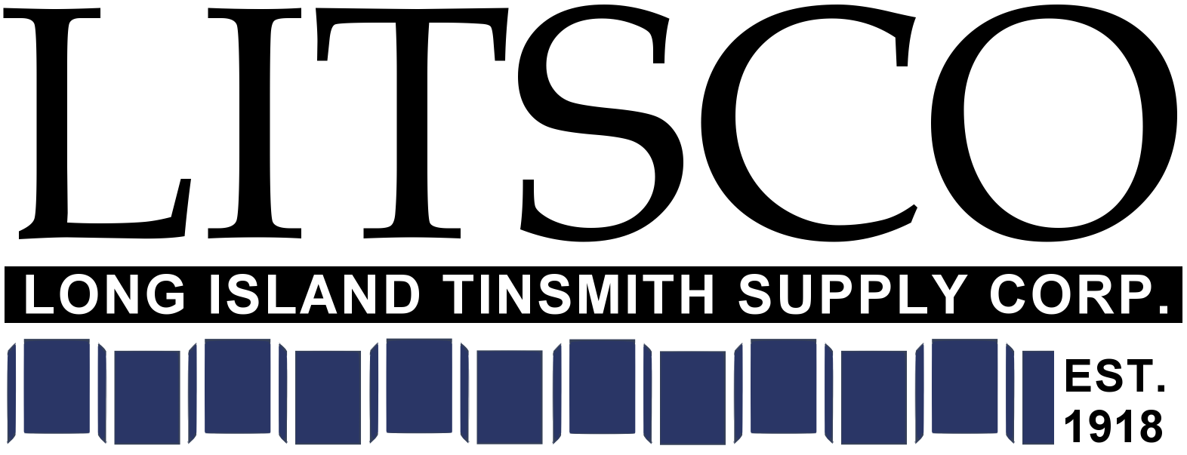
Company Introduction:
Known for our technical expertise in the commercial roofing, building envelope and architectural metal panel industries, LITSCO focuses on distribution of exterior construction products to top-quality professional contractors working in New York City. We combine full-service sheet metal fabrication capabilities with close relationships with select vendors such as Johns Manville, Soprema, Firestone, Carlisle Coatings (CCW), Pecora, Centria, and BASF. We are more than just order takers: clients come to us for consultation on plans, specifications, and detailing of their projects. Our team focuses on value-added services and logistics capabilities such as rooftop deliveries, in-house roof and façade shop drawings, project materials management, and accurate client billing.
Job Title (sub): Sales Development Specialist
Essential Functions
As a Sales Development Specialist, this position offers the opportunity to focus on business development and project materials. The candidate must have proven experience in commercial construction material sales, basic knowledge of the building envelope assemblies from the foundation to the roof, and track and follow sales opportunities. The position requires handling incoming inquiries from customers, as well as developing opportunities with new customers. The position involves both presences inside our office and customer visits in the field. Our ideal candidate has construction sales experience in our market, excellent presentation, willingness to learn, a competitive attitude, and a solution-driven approach to materials and project management. Effective networking within our industry and the ability to absorb and qualify market information is a key part of this position.
- Performing local sales calls and working from the inside to understand customer needs and providing customers with information, support and solutions.
- Sales presentations to prospective and present clients; calculating and quoting prices, taking orders and closing transactions.
- Contacting prospects and explaining features and merits of products or services offered, answering all questions concerning a product or service, with appropriate referrals where required.
- Responsible for developing, growing and maintaining long-term cooperative relationships with clients allowing you to own the relationship and be the main point of contact.
- Handle incoming inquiries from customers via phone, email, walk-ins, as well as from internal references.
- Responsible for taking account leads and ensuring success for the entire lifecycle using a CRM.
- Monitor market conditions, product innovations, and competitors’ products, prices and sales.

Skill Requirements
- Experience with commercial roofing, waterproofing, sealants, concrete repair products and/or metal wall panels
- Utilizing persuasive sales and negotiation techniques
- Knowledge of building envelope assemblies from the foundation to the roof.
- Familiarity with New York City construction industry markets
- 2+ years construction sales, preferably waterproofing and/or concrete repair
- 2+ years of college or military service
- Self-motivated, independent, reliable
- Ability to work with a variety of people including those with English as a second language
- Strong communication skills – both verbal and written
- Ability to develop bills of materials, quantity estimates, and full quotations to clients
- Ability to read specifications and plans
- Proficient computer skills and familiarity with Microsoft Office products such as Word,
Outlook, Excel, and takeoff programs such as Bluebeam
- Valid Driver’s license and insurable driving record

Physical Demands

The physical demands described here are representative of those that must be met by an employee to perform the essential functions of this job successfully. The employee is occasionally required to sit; climb or balance; and stoop, kneel, or crouch. The employee must occasionally lift and/or move up to 10 pounds.

Benefits

Competitive base salary plus bonus
Health Benefits
Vision and Dental Benefits
Health Reimbursement Account
401(k)/ Profit Sharing
Eligible for company provided vehicle or personal vehicle usage reimbursement
Cell phone reimbursement
Note: Eligible for benefits as of hire date

Vacation, Personal time-off and Sick
10 paid holidays

Monday – Friday

This position is eligible for bonuses.

